Lecture#3 Classes in Dart
Objectives
- If-else
- Loop
- Functions
- Classes
- Constructor
  - Un Named
  - Named
- Getter and Setter
- Inheritance

If-else
void main (){
int num1= 50;
if(num1%2==0)
print("Even");
else
print("Odd");
// turnery if else
num1%2==0 ? print("Even") : print("ODD");
}
Printing data using loop
void main(){
List<int> numbers= [ 52, 46 , 44 ,56 ];
for(int n in number){
print(n);
}
for(int i=0;i<numbers.length;i++){
print(numbers[i]);
}
}

Functions:
// Parameter less and not returning any value
void Print()
{
print('this function does not return any value');

}
// In dart function a function having single line can be
// written as
void Print1()=> print('this function does not return any value');

// function receving paramaeters and returning value
int add(int x,int y)
{
return x+y;

}
// above method can be written as using arrow
int add1(int x,int y)=>x+y;
Named Parameters
//Named Parameters are written inside curly brackets and required key word is use
int sum({required int x,required int y})=> x+y;
void main() {
//calling
sum(x: 10, y: 20);
//during calling sequence can be changed
sum(y:20, x: 15);
}

Named and without named parameter
// w is not a named parameter
// value for w will be provided without
// first value given will be assigned to w
int sum(int w,{required int x,required int y})=> w+x+y;
void main() {
//56 will be assigned to w
sum(56,x: 10, y: 20);
//during calling sequence can be changed
// 45 will be assigned to w
sum(45,y:20, x: 15);
}

Optional Arguments
// return type of method is integer or null value
int? Sum({int ?x,int? y}){
if(x!=null && y!=null)
return x+y;
else
return null;

}
void main() {
// calling
/* value for x an y will be null
method will return null an will store null
in res*/
int? res=Sum();

/*
value for x is 10 and y null
method will return null an will store null
in res
*/
res=Sum(x: 10);
/*
value for x is 20 and y is 25 null
method will return 45 and res will have 45
*/
res=Sum(x:20,y:25);

}

Dynamic parameters and Dynamic return type
// return type of method is dynamic
// x and y are also dynamic
// Function will return sum of x and y if integer value is
// provided for both parameters
// If both parameters are string it will concate and return
// error will be thrown if types are not compatible with + operator

Operate(x,y){
return x+y;
}
void main() {
// x is assigned 20 and y is assigned 30
dynamic result=Operate(20,30);
print(result); // result will have value 50

result=Operate("Test"," dart");
print(result); // result will have value Test dart

result=Operate("Test",29); // run time error
}

Classes;
class Student
{
// data memebers
}

class Student
{
// error data members must be initialized
int id;
String name;
}

We will require a constructor to initialize above data members.
class Student
{

int id;
String name;
Student(int id,String name){
this.id=id;
this.name=name;
}
// still an error in dart data members must be //initialized inside parenthesis of constructor
}

class Student
{
int id;
String name;
Student(this.id,this.name);
//correct constructor initialize all data members
// body can be defined if required
}

What if we do not want a constructor?
class Student
{

int? id;
String? name;
// In this class no constructor is required because // default value for id and name are null

}
We can make a late initialization by using late key word before data member.
class Student
{
late int id;
late String name;
// now id and name will be initialized late
}In dart
class Student
{

int id;
String name;
// named parameters
Student({required this.id,required this.name});

}

void main() {
// creating Student object
// can use new key word before constructor
Student s= Student(id: 1,name: "Jibran");

}
Required and optional arguments in constructors
class Student
{
int id;
String? name;
// id is compulsory and name is optional argument
Student({required this.id,this.name});
}
void main() {
// creating Student object
Student s= Student(id: 1,name: "Jibran");

// value for name will be null
Student s1=new Student(id: 2);
}
class Student
{
int id;
String? name;
double cgpa;
// 1st value will be of cgpa
// id and name are named parameters
// name is optional where id is required
// if value of name is not provided it will be null
Student(this.cgpa,{required this.id,this.name});
}
void main() {
// creating Student object
Student s= Student(20.5,id: 1,name: "Jibran");
// value for name will be null
Student s1=new Student(30.5,id: 2);

}

Constructors
In dart constructors are categorized into two types
- Un Named
- Named
Un Named Constructor
- Class can have only one un named constructor
- Un named constructor have similar name to the name of class
Named Constructor
- Class can have more than one named constructor
- Named constructor can be of any name
- Syntax for Named constructor is
Name of Class. Name of Constructor ( )
Example:
class Student
{
int id;
int? age;
String name;
String? address;
//id and name must be initialized inside constructor
// age and name are optional
Student(this.id,this.name);
// below line is error as class can have one named constructor. If another constructor is required than it must be a named constructor
Student(this.id,this.address,this.age,this.name);
}

class Student
{
int id;
int? age;
String name;
String? address;
// id and name must be initialized inside constructor
// age and name are optional
Student(this.id,this.name);

// here InitializeAll is the name of constructor you can use any name
Student.InitializeAll(this.id,
this.address,
this.age,this.name);
}
void main() {
// Un named constructor calling
Student s=Student(1, "Umair");
//Named Constructor calling
Student s1= Student.InitializeAll(1, "Islamabd", 21, "Raza")

}

Getter and Setter
Getter
For creating a getter for any data member get key word is used with given syntax.

return type get name of getter{ return variable name; }
OR
return type get name of getter variable name;

Setter
set key word is used for creating a setter.
set name of setter (data type identifier name){assigning value }
OR
set name of setter (data type identifier name)assigning value
For example if we want to make getter and setter for id having data type int it would be like
Getter
int get getID => id;
ORor
int get getID { return id; }

Setter
set setId(int id)=> this.id=id;
OR
set setId(int id){ this.id=id;}
Example code:
class Student
{
int id;
String name;
Student(this.id,this.name);
//getter for id
int get getID => r id;
// getter for name
String get getName {
return name;
}
//setter for id
set setId(int id)=> this.id=id;
//setter for name
set setName(String name){
this.name=name;
} }

Inheritance
Inheritance in dart is defined as the process in which one class derive the properties and characteristics of another class. It is helpful as it provides an ability with which we can create a new class from an existing class.
Inheritance is a major component of a programming paradigm known as OOPS (Object-Oriented Programming).
With the help of Inheritance, one class can make use of all the properties and characteristics of another class.
In general, two classes are required for inheritance and these mainly are −
- Parent class - A class that is inherited by the other class is known as the parent class. Sometimes, we also refer it to as the base class.
- Child class - A class that inherits the properties and characteristics of the parent class is known as child class.

Syntax
The syntax for a class to inherit the properties and characteristics of another class looks something like this −
class Childclass extends ParentClass {
…
}
Whenever a child class wants to inherit the properties and characteristics of a parent class, we make use of the extends keyword.
There are different types of inheritance that are possible in Dart. Mainly these are −
- Single level inheritance
- Multi-level inheritance
- Hierarchal inheritance

Single Level Inheritance
In the single inheritance, a class is inherited by a single class or subclass is inherited by one parent class. In the following example, we create Person which inherits Human class.
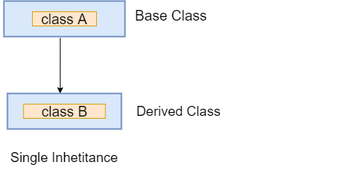
Let's understand the following example.
Example -
class Bird{
void fly()
{
print("The bird can fly");
}
}
// Inherits the super class
class Parrot extends Bird{
//child class function
void speak(){
print("The parrot can speak");
}
}
void main() {
// Creating object of the child class
Parrot p=new Parrot();
p.speak();
p.fly();
}

Output
The parrot can speak
The bird can fly
Explanation:
In the above code, we create parent class Bird and declared the fly() function in it. Then, we created the child class called Parrot, which inherited the parent class's property using the extends keyword. The child class has its own function speak().
Now the child class has two functions fly() and speak(). So we created the object of child class and access both functions. It printed the result to the console.

Hierarchical Inheritance
In the hierarchical inherence, two or more classes inherit a single class. In the following example, the two-child classes Peter and James inherit the Person class.
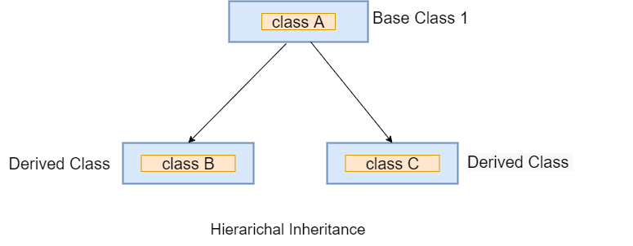
Example -
class Person {
void dispName(String name) {
print(name);
}

void dispAge(int age) {
print(age);
}
}

class Employee extends Person {

void dispBranch(String nationality) {
print(nationality);
}
}
//Derived class created from another derived class.
class Student extends Person {
void result(String result){
print(result);
}
}
void main() {
// Creating Object of Student class
Student j = new Student();
j.dispName("Ali");
j.dispAge(24);
j.result("Passed");

// Creating Object of Employee class
Employee p = new Employee();
p.dispName("Ahmad");
p.dispAge(21);
p.dispBranch("Computer Science");
}
Output
Ali
24
Passed
Ahmad
21
Computer Science

Calling super class Constructors
class Person
{
String name;
String gender;
Person(this.gender,this.name);
}
class Student extends Person
{
int id;
// Calling super class contructor
Student(this.id):super("male","Ali");
}

Abstract Class
An Abstract class in Dart is defined as those classes which contain one or more than one abstract method (methods without implementation) in them. Whereas, to declare an abstract class we make use of the abstract keyword. So, it must be noted that a class declared abstract may or may not include abstract methods but if it includes an abstract method then it must be an abstract class.
Features of Abstract Class:
- A class containing an abstract method must be declared abstract whereas the class declared abstract may or may not have abstract methods i.e. it can have either abstract or concrete methods
- A class can be declared abstract by using abstract keyword only.
- A class declared as abstract can’t be initialized.
- An abstract class can be extended, but if you inherit an abstract class then you have to make sure that all the abstract methods in it are provided with implementation.
Generally, abstract classes are used to implement the abstract methods in the extended subclasses.
Syntax:
abstract class class_name {

// Body of the abstract class
}
abstract class Shape {
//declaring propreties
int height;
int width;

//declaring abstract method
void area();
}

class Rectangle extends Shape{
Rectangle(int a, int b) {
height = a;
width = b;
}
// Overriding method
@override
void area() {
print("Area of rectangle is ${height * width}");

}

}

class Triangle extends Shape{

Triangle(int a, int b) {
height = a;
width = b;
}
// Overriding method
@override
void area() {
print("Area of triangle is ${height * width * 0.5}");

}

}

void main() {

// Creating Object of class Rectangle
Rectangle rect = new Rectangle(6, 3);

// Creating Object of class Triangle
Triangle triangle = new Triangle(21, 6);

rect.area();
triangle.area();
}

Lecture#4 Widgets
Objectives
- Widget
  - Stateless
  - Stateful
- First App
  - Widget Tree
- Layout Widgets
- Centre
- Text
- Container
Widgets:
Each element on a screen of the Flutter app is a widget. The view of the screen completely depends upon the choice and sequence of the widgets used to build the app. And the structure of the code of an app is a tree of widgets.
Category of Widgets:
There are mainly 14 categories in which the flutter widgets are divided. They are mainly segregated on the basis of the functionality they provide in a flutter application.
- Accessibility: These are the set of widgets that make a flutter app more easily accessible.
- Animation and Motion: These widgets add animation to other widgets.
- Assets, Images, and Icons: These widgets take charge of assets such as display images and show icons.
- Async: These provide async functionality in the flutter application.
- Basics: These are the bundle of widgets that are absolutely necessary for the development of any flutter application.
- Cupertino: These are the ios designed widgets.
- Input: This set of widgets provides input functionality in a flutter application.
- Interaction Models: These widgets are here to manage touch events and route users to different views in the application.
- Layout: This bundle of widgets helps in placing the other widgets on the screen as needed.
- Material Components: This is a set of widgets that mainly follow material design by Google.
- Painting and effects: This is the set of widgets that apply visual changes to their child widgets without changing their layout or shape.
- Scrolling: This provides scroll ability of to a set of other widgets that are not scrollable by default.
- Styling: This deals with the theme, responsiveness, and sizing of the app.
- Text: This displays text.

Types of Widgets:
There are broadly two types of widgets in the flutter:
- Stateless Widget
- Stateful Widget
Stateless
Stateless widgets do not require mutable state, i.e., it is immutable. In simple words, Stateless widgets cannot change their state during the runtime of the app, which means the widgets cannot be redrawn while the app is in action. The structure of a Stateless widget looks like this:
class StartScreen extends StatelessWidget {
const StartScreen({Key? key}) : super(key: key);
@override
Widget build(BuildContext context) {
return Container( );
} }
The name of this Stateless Widget is “StartScreen”, inside which we have to override the “build” method. This build method takes in a “BuildContext” as the parameter and returns a widget. That’s why you can see that the return type of the build method is a widget. And this the place where you can design the UI of this screen, which is Stateless.
In Stateless widget, the “build” method can be called only ONCE while the app is in action, which is responsible for drawing the widgets on to the device screen.

Note: If you want to redraw the Stateless Widget, then you will need to create a new instance of the widget.
Some examples of Stateless widgets are as follows:
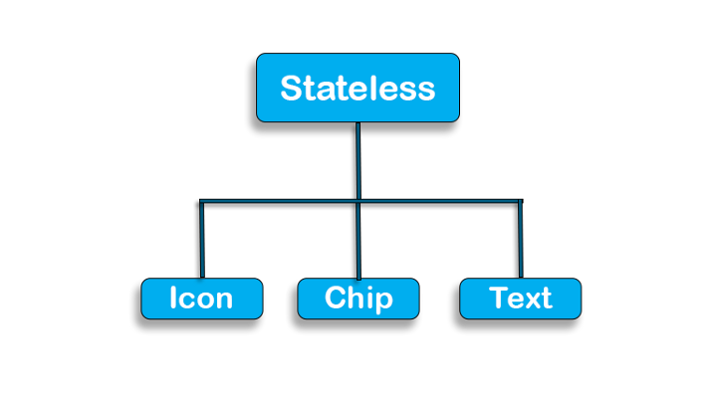
Stateful
Stateful widgets have a mutable state, i.e., they are mutable and can be drawn multiple times within its lifetime. They are the widgets which can change their state multiple times and can be redrawn on to the screen any number of times while the app is in action. The structure of a Stateful widget looks like this:
class StartScreen extends StatefulWidget {
const StartScreen({Key? key}) : super(key: key);
@override
State<StartScreen> createState() => _StartScreenState();
}
class _StartScreenState extends State<StartScreen> {
@override
Widget build(BuildContext context) { } }
The name of the widget is again “StartScreen”, but now it overrides the “createState” method, instead of the “build” method, which returns the instance of the class “_StartScreenState”. The class “_StartScreenState” extends from State<> which takes “StartScreen” as a template input.Now, this “_StartScreenState” overrides the “build” method and returns a widget. This is where you can define the UI of the app, which is Stateful. As it is a Stateful widget you can call the build method any number of times, which will redraw the widgets on the screen.
So, how can you call the build method?
It’s really easy, you can use the “setState” method to call the build method, which will, in turn, redraw the widgets. This is the most important method you will need to use with any Stateful widget, to really use the statefulness of the widget.
Some examples of Stateful widgets are as follows:
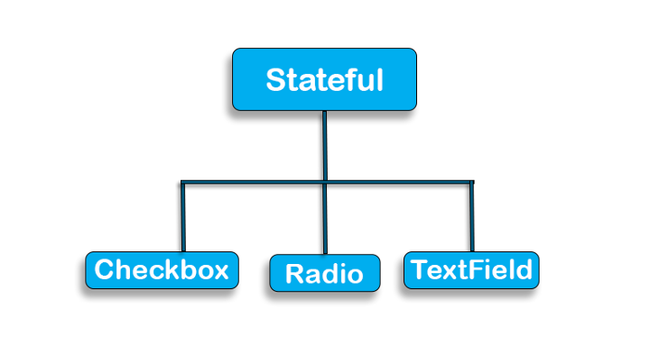
First App
When the project is created, you will get a fully working Flutter application with minimal functionality. You also need an emulator to display output
Code of first app:
void main() {
runApp(const MyApp());
}

class MyApp extends StatelessWidget {
const MyApp({Key? key}) : super(key: key);

@override
Widget build(BuildContext context) {
return MaterialApp(
title: 'Flutter Demo',
theme: ThemeData(

primarySwatch: Colors.blue,
),
home: const MyHomePage(title: 'Flutter Demo Home Page'),
);
}
}

class MyHomePage extends StatefulWidget {
const MyHomePage({Key? key, required this.title}) : super(key: key);

final String title;

@override
State<MyHomePage> createState() => _MyHomePageState();
}

class _MyHomePageState extends State<MyHomePage> {
int _counter = 0;

void _incrementCounter() {
setState(() {

_counter++;
});
}

@override
Widget build(BuildContext context) {

return Scaffold(
appBar: AppBar(

title: Text(widget.title),
),
body: Center(

child: Column(

mainAxisAlignment: MainAxisAlignment.center,
children: <Widget>[
const Text(
'You have pushed the button this many times:',
),
Text(
'$_counter',
style: Theme.of(context).textTheme.headline4,
),
],
),
),
floatingActionButton: FloatingActionButton(
onPressed: _incrementCounter,
tooltip: 'Increment',
child: const Icon(Icons.add),
),
);
}
}

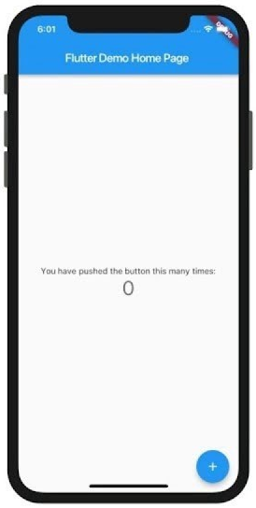
Widget Tree:
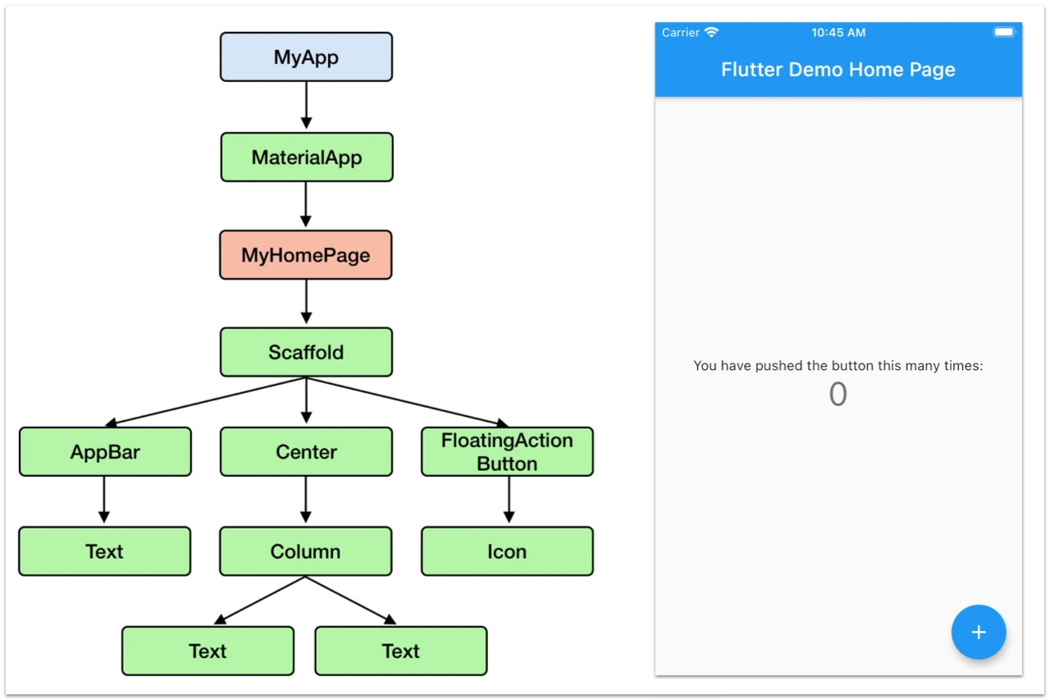
Layout Widgets
The layout is a user interface design pattern that refers to defining how the widgets are displayed on the screen relative to each other.
Flutter categories layout widgets into two types
- Single Child Widget
- Multi-Child Widget
Single Child Widget: The single child layout widget is a type of widget, which can have only one child widget inside the parent layout widget. Best Examples are Container, Padding, Center, Align, SizeBox, Baseline, Card, ListTile, etc.
Center(
child: Text(‘Welcome to Flutter Tutorial’)
),
Multiple Child Widget: The multiple child widgets are a type of widget, which contains more than one child widget. Best Examples are Row, Column, ListView, Expanded, Table, Flow, Stack, etc.
Row(
children: <Widget>[
Text(‘First Child of Row’),
Text(‘Second Child of Row’),])
Centre Widget:
Center widget comes built-in with flutter, it aligns its child widget to the center of the available space on the screen. The size of this widget will be as big as possible if the widthFactor and heightFactor properties are set to null and the dimensions are constrained. And in case the dimensions are not constrained and the widthFactor and HeightFactor are set to null then the Center widget takes the size of its child widget. Let’s understand this with the help of examples.

Constructor:
Syntax:
Center({Key key,
double widthFactor,
double heightFactor,
Widget child})

Properties of Center Widget:
- widthFactor: This property takes a double value as a parameter and it sets the Center widget’s width as the same as the child’s width multiplied by this factor. For example, if it is set to 3.0 then the Center widget will take three times the size of its child widget.
- heightFactor: This property also takes in a double value as a parameter and it sets the Center widget’s height as the same as the child’s height multiplied by this factor.
- Child: This property takes in a widget as a parameter to be displayed inside the Center widget on the screen.
- alignment: This property takes in AlignmentGeometry as the parameter value to determine how the child widget will be aligned with respect to the Center widget.
Text
A Text is a widget in Flutter that allows us to display a string of text with a single line in our application. Depending on the layout constraints, we can break the string across multiple lines or might all be displayed on the same line. If we do not specify any styling to the text widget, it will use the closest DefaultTextStyle class style. This class does not have any explicit style. In this article, we are going to learn how to use a Text widget and how to style it in our application.
Constructor:
Text(
String this.data, {
Key? key,
this.style,
this.strutStyle,
this.textAlign,
this.textDirection,
this.locale,
this.softWrap,
this.overflow,
this.textScaleFactor,
this.maxLines,
this.semanticsLabel,
this.textWidthBasis,
this.textHeightBehavior,
})

Container:
Constructors of the container class
The following are the syntax of container class constructor:
Container({Key key,
AlignmentGeometry alignment,
EdgeInsetsGeometry padding,
Color color,
double width,
double height,
Decoration decoration,
Decoration foregroundDecoration,
BoxConstraints constraints,
Widget child,
Clip clipBehavior: Clip.none
});

Properties of Container widget
Let us learn some of the essential properties of the container widget in detail.
1. child: This property is used to store the child widget of the container. Suppose we have taken a Text widget as its child widget that can be shown in the below example:
Container(
child: Text("Hello! I am in the container widget", style: TextStyle(fontSize: 25)),
)
2. color: This property is used to set the background color of the text. It also changes the background color of the entire container. See the below example:
Container(
color: Colors.green,
child: Text("Hello! I am in the container widget", style: TextStyle(fontSize: 25)),
)
3. height and width: This property is used to set the container's height and width according to our needs. By default, the container always takes the space based on its child widget. See the below code:
Container(
width: 200.0,
height: 100.0,
color: Colors.green,
child: Text("Hello! I am in the container widget", style: TextStyle(fontSize: 25)),
)
4. margin: This property is used to surround the empty space around the container. We can observe this by seeing white space around the container. Suppose we have used the EdgeInsets.all(25) that set the equal margin in all four directions, as shown in the below example:
Container(
width: 200.0,
height: 100.0,
color: Colors.green,
margin: EdgeInsets.all(20),
child: Text("Hello! I am in the container widget", style: TextStyle(fontSize: 25)),
)
5. padding: This property is used to set the distance between the border of the container (all four directions) and its child widget. We can observe this by seeing the space between the container and the child widget. Here, we have used an EdgeInsets.all(35) that set the space between text and all four container directions:
Container( width: 200.0,
height: 100.0,
color: Colors.green,
padding: EdgeInsets.all(35),
margin: EdgeInsets.all(20),
child: Text("Hello! I am in the container widget", style: TextStyle(fontSize: 25)),
)
6. alignment: This property is used to set the position of the child within the container. Flutter allows the user to align its element in various ways such as center, bottom, bottom center, topLeft, centerRight, left, right, and many more. In the below example, we are going to align its child into the bottom right position.
Container(
width: 200.0,
height: 100.0,
color: Colors.green,
padding: EdgeInsets.all(35),
margin: EdgeInsets.all(20),
alignment: Alignment.bottomRight,
child: Text("Hello! I am in the container widget", style: TextStyle(fontSize: 25)),
)
7. decoration: This property allows the developer to add decoration on the widget. It decorates or paint the widget behind the child. If we want to decorate or paint in front of a child, we need to use the forgroundDecoration parameter. The below image explains the difference between them where the foregroundDecoration covers the child and decoration paint behind the child.
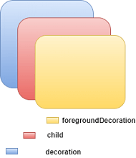
The decoration property supported many parameters, such as color, gradient, background image, border, shadow, etc. It is to make sure that we can either use the color property in a container or decoration, but not in both. See the below code where we have added a border and shadow property to decorate the box:
import 'package:flutter/material.dart';

void main() => runApp(MyApp());

/// This Widget is the main application widget.
class MyApp extends StatelessWidget {

@override
Widget build(BuildContext context) {
return MaterialApp(
home: Scaffold(
appBar: AppBar(
title: Text("Flutter Container Example"),
),
body: Container(
padding: EdgeInsets.all(35),
margin: EdgeInsets.all(20),
decoration: BoxDecoration(
border: Border.all(color: Colors.black, width: 4),
borderRadius: BorderRadius.circular(8),
boxShadow: [
new BoxShadow(color: Colors.green, offset: new Offset(6.0, 6.0),),
],
),
child: Text("Hello! I am in the container widget decoration box!!",
style: TextStyle(fontSize: 30)),
),
),
);
}
}

Code
import 'package:flutter/material.dart';
void main() => runApp(MyApp());
class MyApp extends StatelessWidget {
@override
Widget build(BuildContext context) {
return MaterialApp(
home: Scaffold(
appBar: AppBar(
title: Text("Flutter Container Example"),
),
body: Container(
padding: EdgeInsets.all(35),
margin: EdgeInsets.all(20),
decoration: BoxDecoration(
border: Border.all(color: Colors.black, width: 4),
borderRadius: BorderRadius.circular(8),
boxShadow: [
new BoxShadow(color: Colors.green, offset: new Offset(6.0, 6.0),),
],
),
child: Text("Hello! I am in the container widget decoration box!!",
style: TextStyle(fontSize: 30)),
),
),
);
}
}

